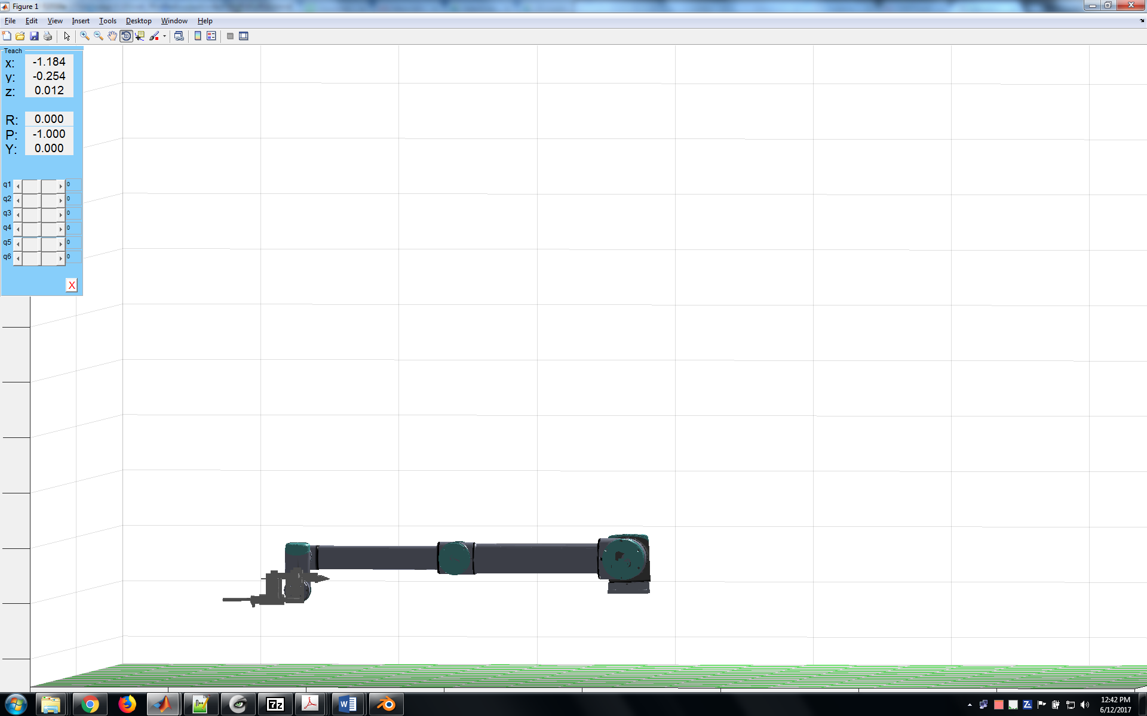

Standing on the negative y size and looking at the robot

+y

-x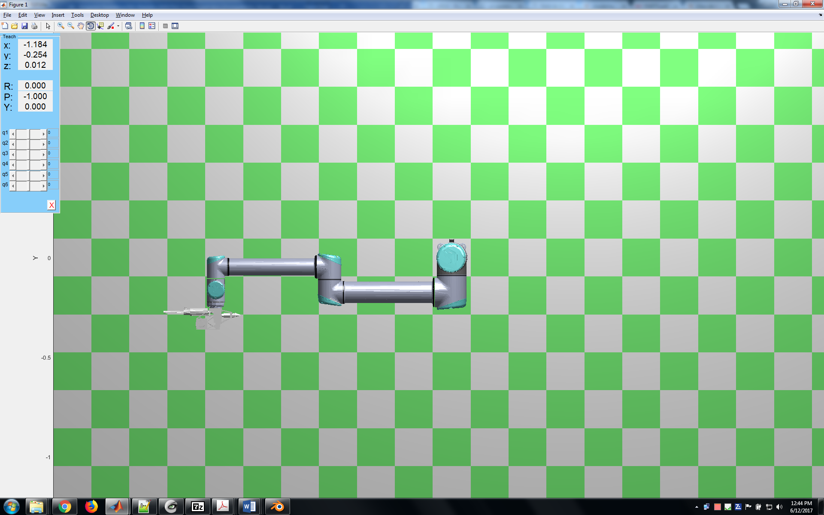+x

-y

Looking from the top